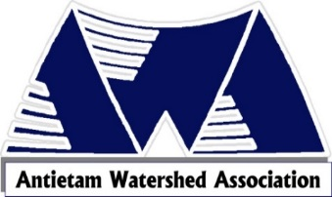 Annual Membership Form 2024
Individual Membership $15.00 Family Membership $25.00

Additional Donation $ ______________
Name(s) ______________________________________________________________________________
Mailing Address __________________________________________________________________________
Email__________________________ Phone (optional) ___________________
Areas of Interest: Please see list below for details.
Planting Projects___ Planting Site maintenance __Board of Directors __ Stream Monitor ____
Rattlesnake Run Road Cleanup___ Financial Support only _____ Outreach programs_____
Program or lecture you would like to see. ________________________________________________________
Special Talent you could provide. (Web Design, etc.)__________________________________
http://www.antietamws.org PO Box 331, Waynesboro, PA 17268

Planting Projects: Organized by the board in cooperation with the local landowners and the Chesapeake Bay Foundation. It involves planting trees (often the holes are predrilled), installing shelters and staking the new plants to protect them.
Planting Site Maintenance: Returning to previous planting sites to reset shelters if needed, and removing shelters when trees are mature enough.
Serve on the Board: Quarterly meetings to discuss projects/ideas. One general membership/public meeting in October, and one public program in conjunction with Renfrew Institute in April. Three-year terms.
Stream Monitoring: You will be trained in the citizen science protocol if you are willing to take water samples at a designated site on the Antietam and/or its tributaries. Tests conducted at least 8 months out of a year. All equipment and chemicals are supplied to you. Records are added to past years’ data.
Rattlesnake Run Road Cleanup: Annually we clean up trash along Rattlesnake Run Road. Planning on a
Financial Support: Funds for educational materials, mailing, pamphlets, water sampling chemicals, projects, and other administrative costs. This is a 100% volunteer organization – no salaries are paid.
Outreach programs: Your help with staffing the AWA booth at community activities (e.g., Renfrew’s Earth Day in April, Waynesboro’s Market Day, etc.) would be appreciated! We distribute educational materials, explain and supervise our “Stream Saver” pinball game, and encourage folks to join and support AWA

